Hatrockhound Gazette 2019
PO Box 1122, Hermiston, Oregon 97838
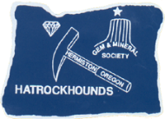
Officers:
President – Bill Shipp
V. Pres. – Mike Filarski
Secretary – Rita Watterson
Treasurer – Mel Lambert
Mbr at Large – Laura Tiffany

Meetings at 6:30 on the 2nd Tuesday of each month
First Christian Church of Hermiston:
775 West Highland
(go to back of church)

Club Contact: Mike Filarski stonemorlin1@netscape.net 541-571-2593
Newsletter/Website – Judi Allison, 1701 NW 11th St, Hermiston, OR 97838 541-720-4950
Jall23.wixsite.com/hatrockhounds
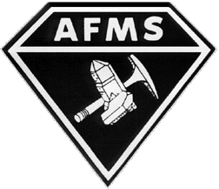
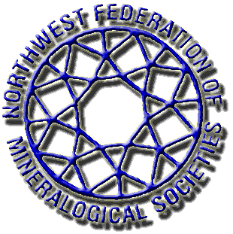
Hatrockhounds Gem and Mineral Society is Affiliated with:

The Northwest Federation of Mineralogical Societies
And The American Federation of Mineralogical Societies

AFMS Rockhounds “Code of Ethics”
I will respect both private and public property and will do no collecting on privately owned land without permission from the owner.
I will keep informed on all laws, regulations or rules governing collecting on public lands and will
observe them.
I will, to the best of my ability, ascertain the boundary lines of property on which I plan to collect.
I will use no firearms or blasting material in collecting areas.
I will cause no willful damage to property of any kind such as fences, signs, buildings, etc.
I will leave all gates as found.
I will build fires only in designated or safe places and will be certain they are completely extinguished before leaving the area.
I will discard no burning material - matches, cigarettes, etc.
I will fill all excavation holes which may be dangerous to livestock.
I will not contaminate wells, creeks, or other water supplies.
I will cause no willful damage to collecting material and will take home only what I can reasonably use.
I will practice conservation and undertake to utilize fully and well the materials I have collected and will recycle my surplus for the pleasure and benefit of others.
I will support the rockhound project H.E.L.P. (Help Eliminate Litter Please) and will leave all collecting areas devoid of litter, regardless of how found.
I will cooperate with field-trip leaders and those in designated authority in all collecting areas.
I will report to my club or federation officers, Bureau of Land Management or other authorities, any
deposit of petrified wood or other materials
on public lands which should be protected for the enjoyment of future generations for public educational and scientific purposes.
I will appreciate and protect our heritage of natural resources.

I will observe the "Golden Rule", will use Good Outdoor Manners and will at all times conduct myself
in a manner which will add to the stature and Public Image of Rockhounds everywhere.
Hatrockhound Gazette - February 2019 Issue
February Meeting: Tuesday, February 12, 2019, 6:30 pm
Creating Rock Critters
With helpful instruction and donation of paint supplies from Laurie, we will paint on rocks so they can be used for prizes at the kids’ corner at the show.
Program will be first this evening with the business meeting after.
Treats by Mel and Louise and Ty and Stella

Hatrockhounds Gem and Mineral Society
Meeting Minutes
January 8, 2019
General Business: Our new officers took their places tonight with a total of nineteen members present. As our new Secretary, Rita Watterson took the minutes, President, Bill Shipp asked if any visitors were present. With none in attendance, he then asked for the treasurer’s report.
Treasurer’s Report: Mel Lambert reported the amount currently in our account. He was also available to accept dues payments.
Correspondence, read by Vice President, Mike Filarski, included a request for sponsorship of a Knight or Lady for the Girl Scouts Father-Daughter banquet. If individuals are interested, they may donate separately. Renewal of membership in the Oregon Council of Rock and Mineral Clubs was a second piece of mail. Gordon Weber and Randy Free both asked what the club receives for its membership. Mike read the highlights of its activities last year, some of which were working to make Forest Service and BLM and other entities aware of what we are about, attendance in meetings about such and rotating displays at the Capitol in Salem. Randy them made a motion to renew and Tonya Abbott seconded the motion. It was carried. Our treasurer will send the $.25 per member, which adds up to $16.75 total. If members want more information about the council or would like to make contact, the email address is igneous80@q.com.
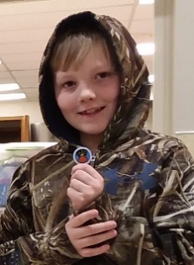
Show Report: Our show will again be at EOTEC on May 11-12. The cost for the entire room will be $2200. Dealers’ fees are being raised by $.25 a foot. There will not be any dealers outside. Mike anticipates having about nineteen dealers. He is still working on the configuration, which will most likely include having the display cases in the show room instead of the lobby as they were last year. We really want to work more on using social media such as Facebook and Craig’s List and starting the process earlier. We will also plan to do the radio spot and the Nickel. There was a question about flyers at the schools. It may not be an option, but Judi said she will check it out. Stella Naillon also asked if someone would come to schools to do rock presentations. Both Judi and Mike stated they had done so before and were willing to do so if asked. Rita was also interested in helping with such.
Old Business: Judi presented both Dylan and Teddy (who was absent) with their Earth Processes badge they had earned awhile back. She also stated the Stella had volunteered to become the Junior Leader. Stella will get some things set and let others know.
President, Bill brought up the suggestion about a donation to the church for its use. Mike moved and Judi seconded that we donate the same amount we did last year to the church. Motion was unanimously carried. Mel will check to see what the amount was last year and make the check accordingly.
Show and Tell:
Moe brought a jasper from China Hollow that belonged to his grandson.
Gordon showed off a piece of “nice gneiss” that had been cut in a square.
Roy wondered about pieces he had gotten from his dad. It was decided they were probably Graveyard Point.
Mike told about the Rock Creek thunderegg he had brought to show.
Door Prizes: Prizes were won by Roy Frazier and Laurie Ellis.
Program: Those present appeared to have a lively time trying their hand at the Rock Jeopardy Game. Although everyone got to choose from the rocks, the winning group was the “kids” table which included Dylan, Ty, Kayla Stella, Laura, Roy and Patty. Coming in second was the group of Gordon, Laurie, Randy and Stan. The “also played” group consisted of Tonya, Maurice, Rita, Mel and Louise; with a little help and kibitzing by Mike. Emcee, Judi, decided perhaps everyone needed some tutorials on the Federation, so guess what kind of information you are going to be finding in your Gazettes this year???
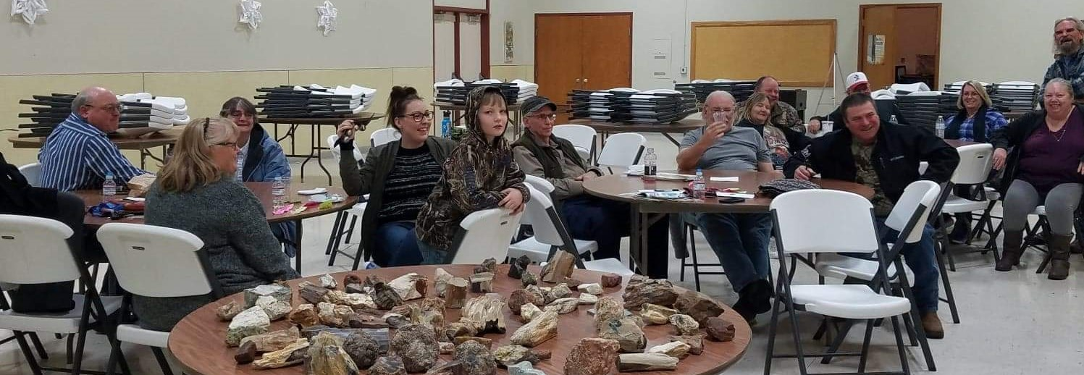
Executive meeting: Wednesday, January 30, 7:00 at Judi’s. Everyone is welcome (Cancelled)
FEBRUARY MEETING: 6:30 pm, February 12th
ROCK PAINTING: Creations to add to the Kids’ Corner prizes at the show.
WEBSITE: jall23.wixsite.com/hatrockhounds
Secretary, Rita Watterson (Transcribed by Judi Allison)

Know Your Federation – Show Coordination, Stamps and AFMS Rockhound of the Year
I chose a couple of the simpler committees to start this process, since you might have actually noticed something relevant to them. Following is the description from the Operating Procedures (OPs) for the Show Coordination Committee. Most of the committees listed in the OPs consist of one person. If you have paid attention to the list of shows at the end of your Northwest Newsletter, thank the Show Coordinator for their appearance. This person (who at present is Pat Lambert of the Lakeside Club in the Tri-Cities) receives information from the clubs about their shows then sends it on to, not only the newsletter, but other publications she has found to help advertise our individual shows. If a club doesn’t send in their information to the show coordinator, they have lost out on a free, painless process of advertising for the show. | SHOW COORDINATION Show Coordination shall: *Accept from the various Member Societies information regarding shows sponsored by them and to register the same on the Show Calendar. *Advise Societies of conflict with prior registrations and to suggest alternate dates. *Send this information to the various gem & mineral publications which carry a show calendar, prior to their regular closing and publication dates. The information so requested shall include the following: date of show, name(s) of the Societies sponsoring the show, title of show, site of show, city and state. *Notify the AFMS Show Coordinator as soon as a bid for a Federation Show is accepted.
The second Committee I chose to highlight in this publication is Stamps. What do stamps have to do with rockhounding, you say? Well, as a nonprofit, we need to be an educational and helping entity. Many years ago, some people with the idea of helping with some aspect of cancer research started this committee. They had members from all the different clubs save the stamps off their letters, then turn them in to them. They in turn, went through the stamps and sold them to a broker for stamp collectors. The money gained was given to cancer research. The process has changed a bit over the years, but still goes toward something related to cancer. Chuck Sonner, who is now chairman, has devised a bit different approach. He sells the stamps through EBay and is able to receive a bit more for them. A couple of years ago the Assembly of Directors (representatives from the individual clubs) voted to donate the funds to a group in the Seattle area called “Knitted Knockers”. This group knits breast pads for mastectomy patients and gives them free of charge to the recipients. So, by saving your stamps, you can also contribute to this worthy cause. | STAMPS Stamps shall: *Arrange for the collection of such postage stamps as may be of value in contributing to cancer research, or other charitable use (amended 1995). *Arrange for disposal (sale) of stamps to convert to dollars. *Forward receipts to the NFMS Treasurer. *Report annual activity and receipts at the Mid-Year and Annual Meetings and through articles submitted to the Northwest Newsletter  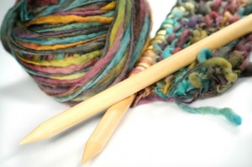  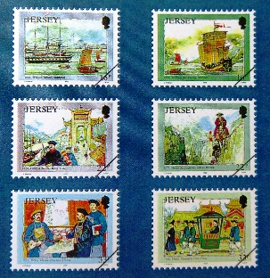
I decided that I also need to add information about the position that our Laurie Ellis holds. Laurie is the NFMS Representative for the AFMS Rockhound of the Year Program. Every club in the entire American Federation (66 in the Northwest) has the opportunity to choose someone as their “Rockhound of the Year”. This is how it works. A club decides on a person or couple to honor for the year. It is usually someone who has contributed something special during that year. The persons can be selected by a committee, the executive committee or a person, depending upon how each club has decided to do so. A short write up is sent to the Chairman in their region: in the Northwest case, that is Laurie. She then passes on the information for publication in the Northwest Newsletter and to the AFMS Rockhound of the Year Chairperson, who in turn submits the information to the AFMS Newsletter and creates a certificate of honor. The certificate is given to Laurie, who in turn passes it to the club submitting the honoree. It is a simple process that can give recognition to some of our hard workers in our clubs, but sadly, not many clubs choose to do this. | I am hoping we can change that trend and get more clubs to participate. Clubs can also submit a Junior Rockhound of the Year to be honored, so keep an eye on the folks in our club. In our club, the executive committee has traditionally chosen the honorees, but if you have an idea please pass it along. We have so many great workers in our clubs. Let’s show them we appreciate them.  